CSEE5590-0005/490-0005

IOT / Robot Programming

LAB ASSIGNMENT #1

Lesson Title: Smart IOT Monitoring Station using Adafruit Visualization

Lesson Description: Adafruit Visualization of the IOT sensors for professional Looks

Lab Report by Team 1: Ahmed, Cameron, Marajan, Syed Jawad

In this lab assignment the task was to make a weather station using IOT tools, like board, sensors, Arduino etc. The job of the sensors was to get the respective reading and send this to a visualization platform. Further there should be color indicators to distinguish between safe and unsafe readings and warning message based on certain conditions should also be displayed. Finally, there should be an on and off switch to control the circuit.

The sensors use in this lab assignment are pulse sensor, Temperature sensor, Light sensor, UV Sensor, Barometer sensor and the dust sensor. C++ code was used to control the board. There was a Wi-Fi module attached to the board to send the readings to the online visualization platform, Adafruit. Led lights were used as color indicator and they turn green for safe range and red for unsafe reading. Threshold values for set for different sensors to indicate safe and unsafe region.

The visualization platform used for this lab assignment is Adafruit. It is an open source platform which allows people to customize data visualization. Visualization interfaces were made for all the sensors on Adafruit visualization platform. All the data collected from sensors at the board were sent to their respective visualization interface at Adafruit visualization platform via WIFI module that was also attached to the board.

There were some challenges that were also faced in completing this lab. Initially, the visualization platform WIFI module was throwing some errors and it took a while to fix that issue. Also sending the data from each sensor one at a time was achieved quickly and accurately but sending all the data together to Adafruit was a challenge but that was accomplished as well.

The YouTube link for the assignment is:

<https://youtu.be/bnB7ZJZPKVs>

The Screen shots for visualization are as follow:

**Temperature and UV:**

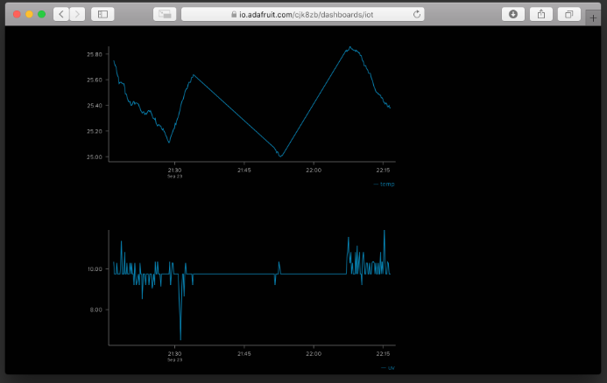

**Barometer and Temperature:**

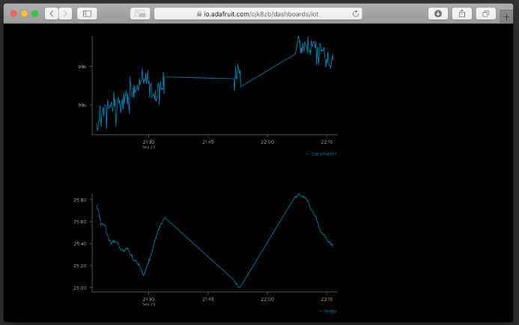

**Light and Dust:**

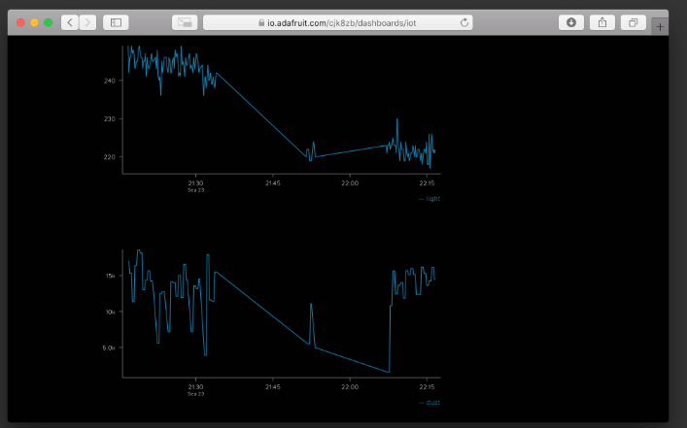

**Humidity and Temp:**

